ALK (C1156Y)
Catalog Number: CR-M 26226
Gene Symbol: ALK, CD246, NBLST3
Description: Anti-ALK (C1156Y) Mouse Monoclonal Antibody

Background: Anaplastic lymphoma kinase (ALK) also known as CD246 (cluster of differentiation 246) is a tyrosine kinase receptor that plays an important role in the development of the brain and nervous systems. Deficiencies in ALK, which most commonly as a fusion with other genes, are indicated in cancers. Immunogen: A synthetic peptide from the internal region of ALK which includes the mutation of C1156Y, human origin.
Tested applications: ELISA, WB, IHC
Recommended dilutions:
ELISA: 1:1000-1:5000
WB: 1:500-1:2000
IHC: 1:50-1:100
Concentration: 1 mg/ml
Host: Mouse
Clonality: Monoclonal
Purity: Purified from ascites
Format: Liquid
Storage buffer:
Preservative: no
Constituents: PBS (without Mg²⁺ and Ca²⁺), pH 7.4, 150 mM NaCl, 50% glycerol
Species Reactivity: Recognizes C1156Y mutant, but not wild-type ALK of vertebrates.
Storage Conditions: Store at -20°C. Avoid freeze / thaw cycles.

Western blot:
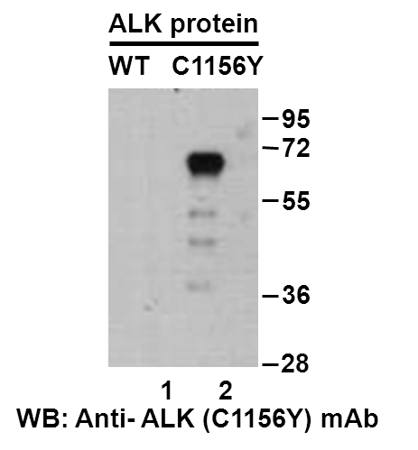
Western blot analysis of recombinant ALK (C1156Y) and wildtype proteins. Purified His-tagged ALK (C1156Y) protein (lane 2) and corresponding wildtype protein (lane 1) were blotted with anti-ALK (C1156Y) monoclonal antibody (Cat. #26226).

Immunofluorescence:
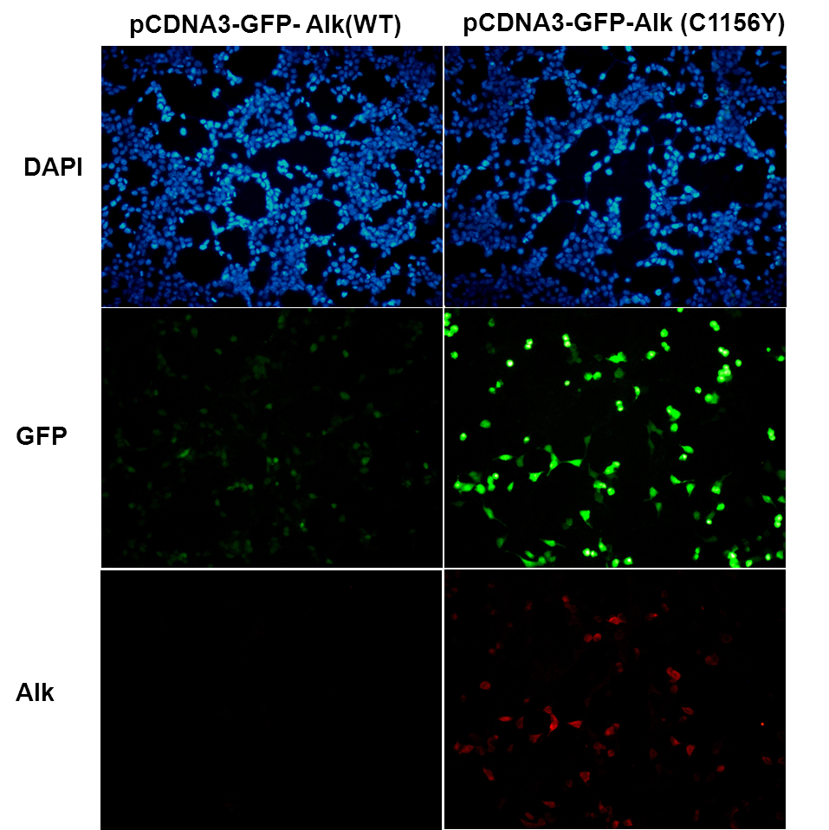
Immunofluorescence of cells expressing ALK proteins with anti-ALK (C1156Y) antibody. HEK293T cells were transfected with pCDNA3-GFP-ALK (WT) plasmid (left column) or pCDNA3-GFP-ALK (C1156Y) plasmid (right column), then fixed and stained with anti-ALK (C1156Y) monoclonal antibody (Cat. #26226).

